1. Create an empty virtual machine with the requested settings:

First we search for the official url for download VirtualBox:
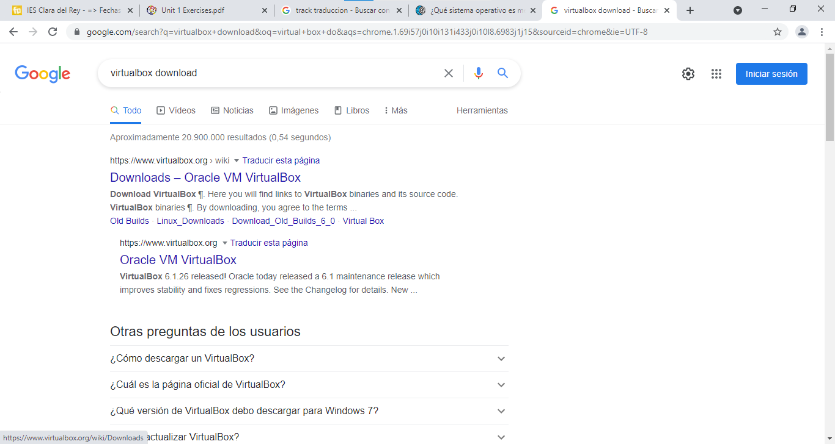
After we enter the correct url, we select our OS and click on it, in our case, we will use Windows Host:
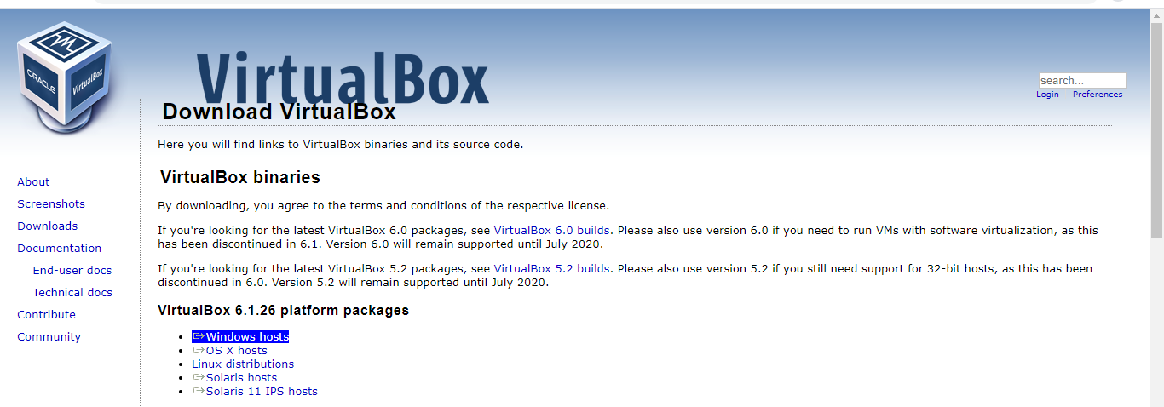
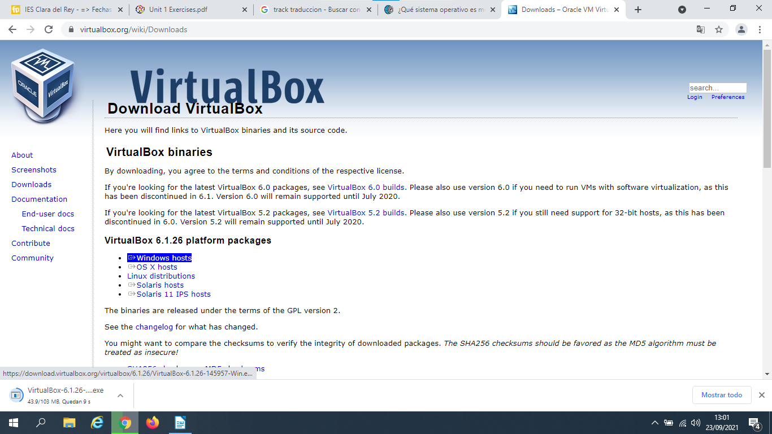
We click on Windorws hosts and the application will start to download.

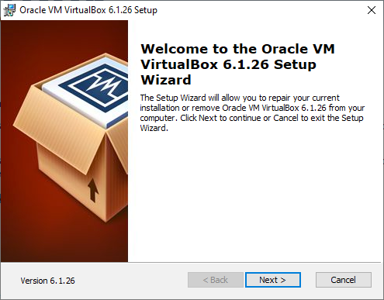
Then, we set up the installation and follow the instructions, in my case, VirtualBox is already installed so I clicked on Cancel option:

On your screen, you must see a shortcut to VirtualBox:
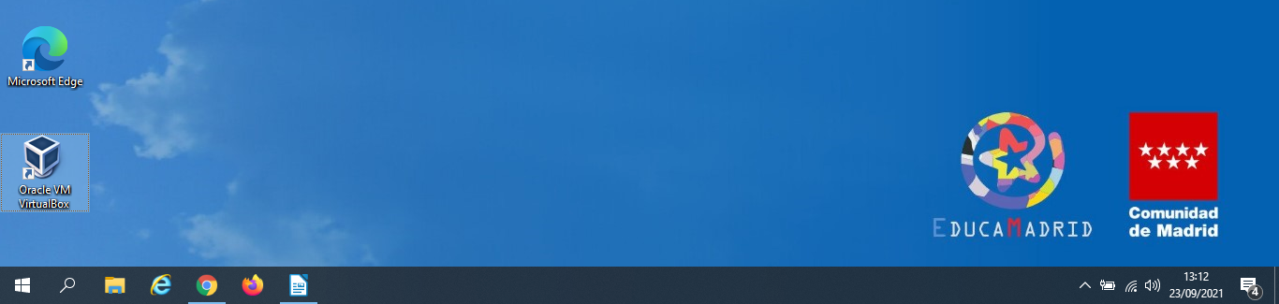

Once you enter the VirtualBox App, you will select the “New” Icon and start creating your virtual machine with the specifications required, in my case, I show you my Virtual machine, created in the classroom:
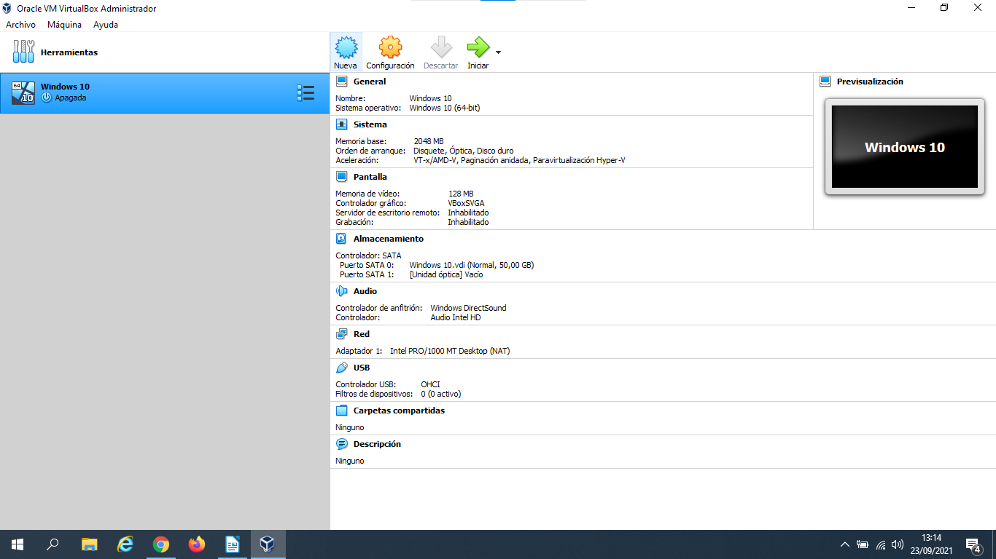

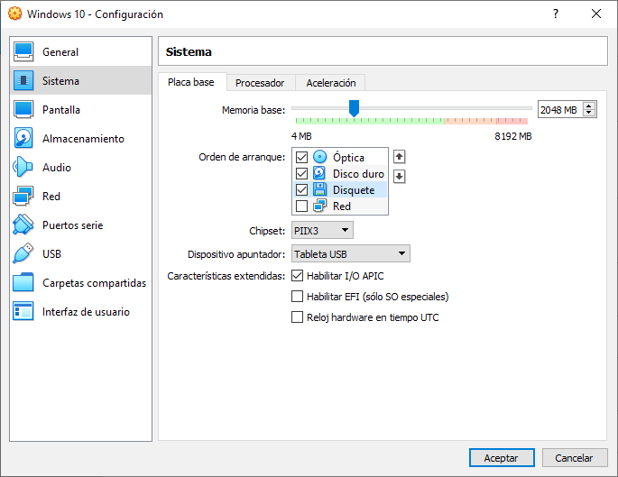
As you can see, there is the Boot order, CD, hard drive and Floppy unit.

To create de 2nd hard drive, you have to chose the icon “add new hard drive” on the option Controlador Sata:
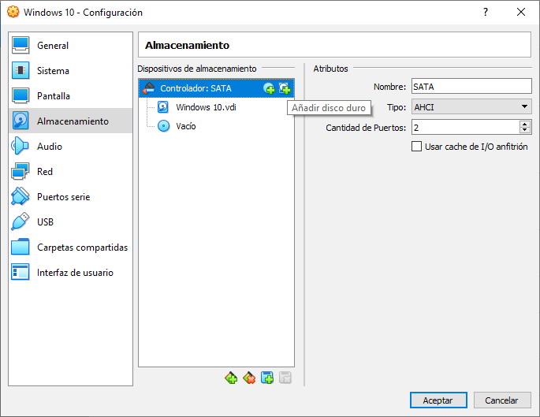

In the second screen, you chose the icon “Create”
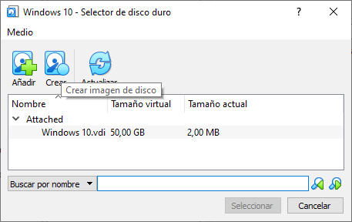

Then you chose the VDI option and the button Next:

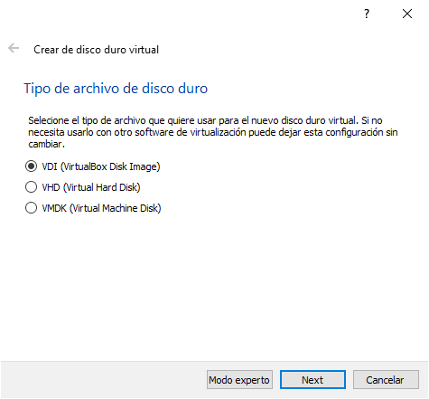
And you chose the option “dynamically reserve”

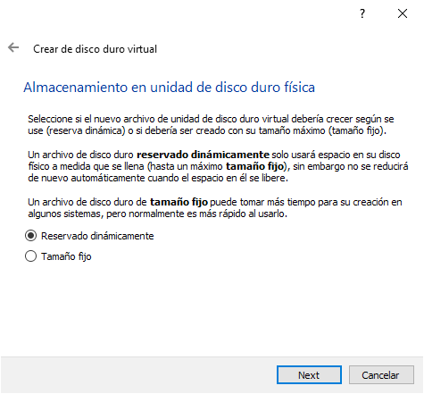

You select the required space size of 30 GB and the option Create:

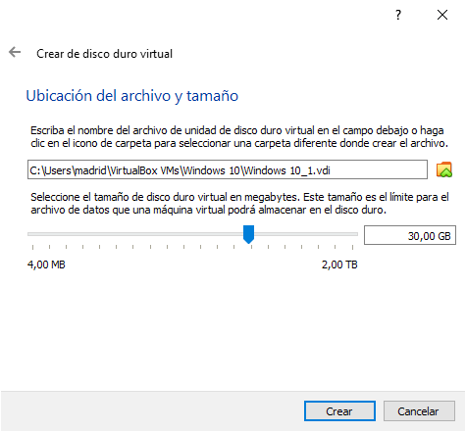

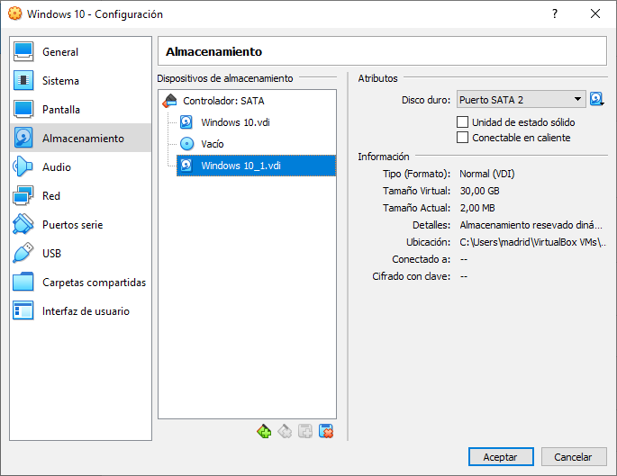

2. Install Windows 10 in the virtual machine from exercise 1.

You must chose the Option Settings, then Storage, the empty storage unit and finally click on the CD icon and chose Select Hard disk file:

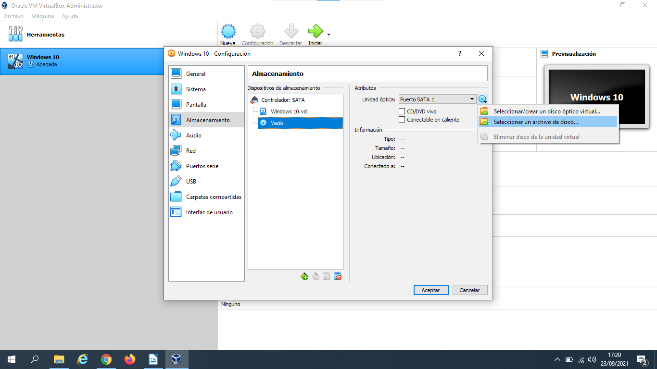

And search for the ISO file of Windows that you are going to install:

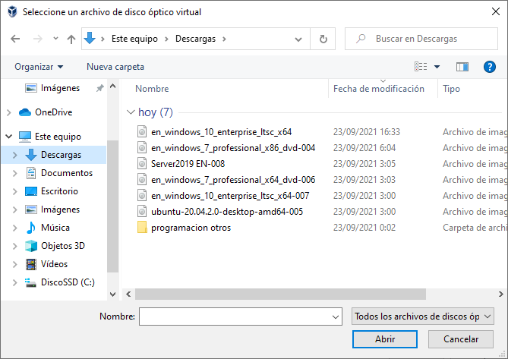

When you select the ISOfile, you click the option Acept:
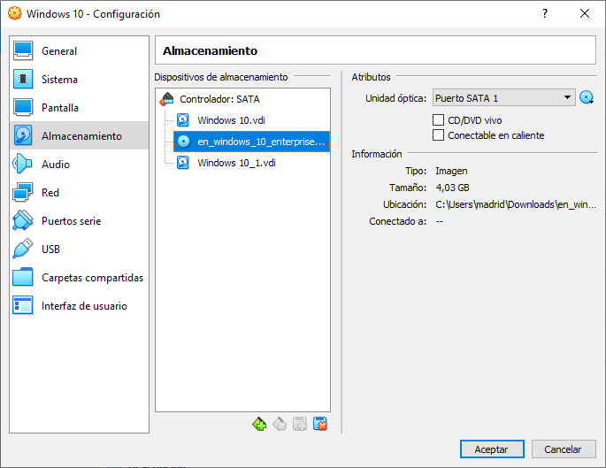

You screen will show you the Window’s set up, you select your lenguage preferences:

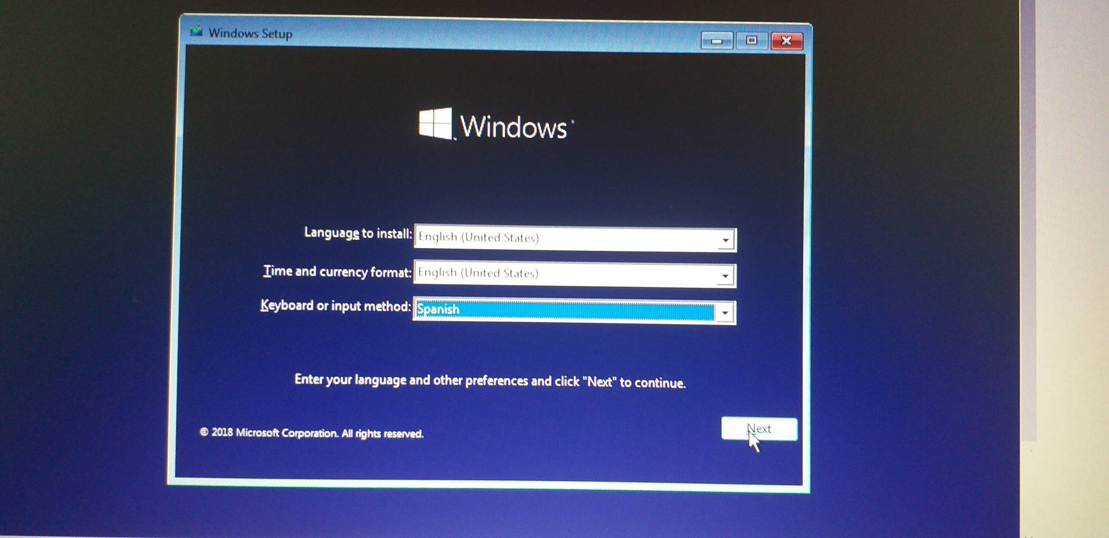

And then, you start installing de software:

